2)import java.util.*;
public class Main

{

public static void main(String[] args)

{

int n, a = 0, b = 0;

Scanner s = new Scanner(System.in);

System.out.println("Author:P.Vamsi sita ram\nSAP ID:51834793");
System.out.print("Enter no. of elements you want in array:");

n = s.nextInt();

int x[] = new int[n];

int odd[] = new int[n];

int even[] = new int[n];

System.out.println("Enter all the elements:");

for(int y = 0; y < n; y++)

{

x[y] = s.nextInt();

}

for(int y = 0; y < n; y++)

{

if(x[y] % 2 != 0)

{

odd[a] = x[y];

a++;

}

else

{

even[b] = x[y];

b++;

}

}

System.out.print("Odd:");

if(a > 1)

{

for(int y = 0;y < (a-1); y++)

{

System.out.print(odd[y]+",");

}

System.out.print(odd[a-1]);

}

else

{

System.out.println("No number");

}

System.out.println("");

System.out.print("Even:");

if(b > 1)

{

for(int y = 0; y < (b-1); y++)

{

System.out.print(even[y]+",");

}

System.out.print(even[b-1]);

}

else

{

System.out.println("No number");

}

}

}
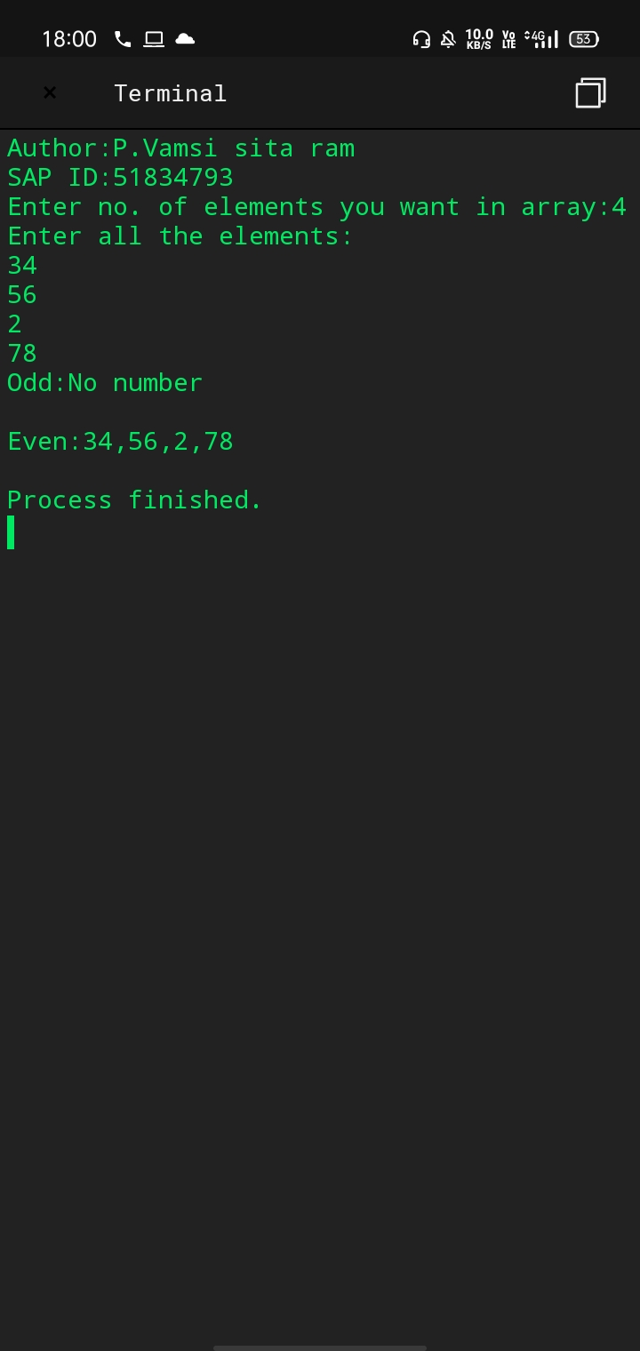

4)public class Main
{
public static void main (String[] args) {
System.out.println("Author:D.Aditya Varma\nSAP ID:51834693");
int A=1;
for (int b=1;b<=5;b++)
{
for (int c=1;c<=b;c++)
{
System.out.print(A);
A++;
}
System.out.println();
}
}
}
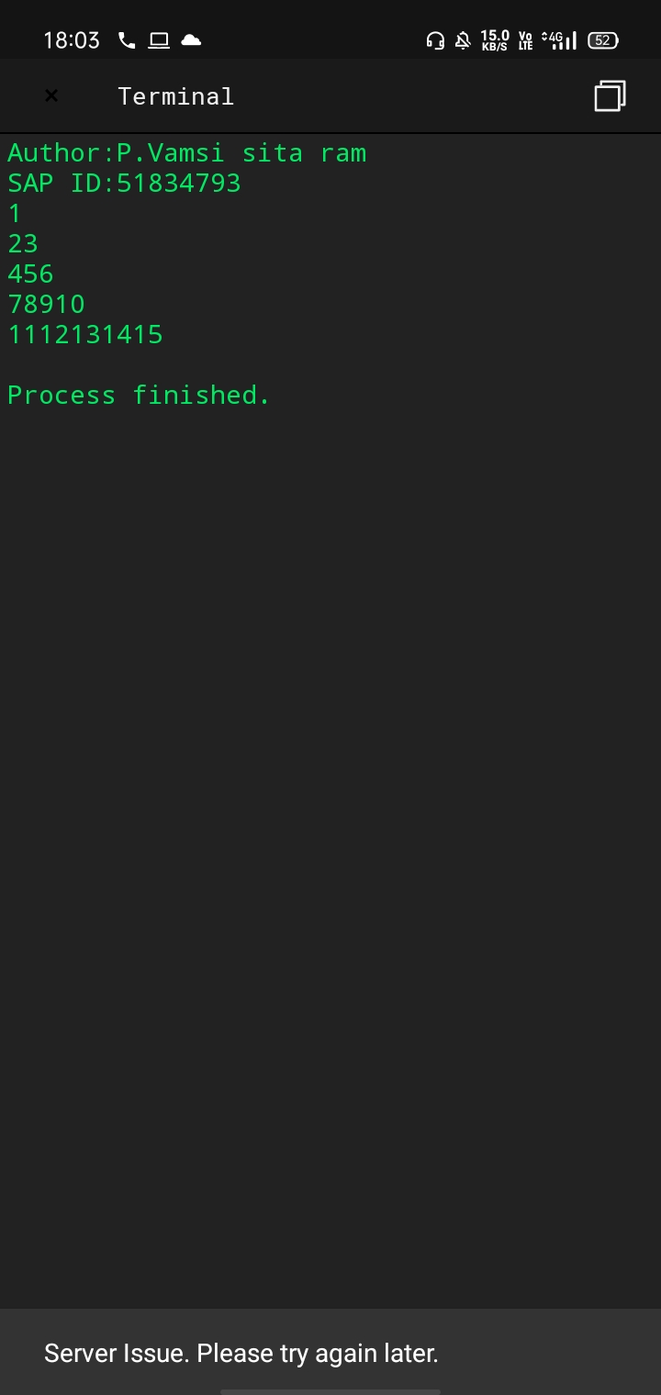

5)import java.util.Scanner;

public class Main

{

public static void main(String[] args)

{

int c;

String temp;

Scanner s = new Scanner(System.in);

System.out.println("Author:P.Vamsi sita ram\nSAP ID:41834793");
System.out.print("Enter number of words you want to enter:");

c = s.nextInt();

String names[] = new String[c];

Scanner s1 = new Scanner(System.in);

System.out.println("Enter all the words line by line:");

for(int a = 0; a < c; a++)

{

names[a] = s1.nextLine();

}

for (int a = 0; a < c; a++)

{

for (int b = a + 1; b < c; b++)

{

if (names[a].compareTo(names[b])>0)

{

temp = names[a];

names[a] = names[b];

names[b] = temp;

}

}

}

System.out.print("words in Sorted Order line:");

for (int a = 0; a < c - 1; a++)

{

System.out.print(names[a] + " ");

}

System.out.print(names[c - 1]);

}

}
